**Project Report**

Implementation of Genetic Programming for Classifying the Diabetes Dataset

**Author: Aryank Gupta and Aayush Thakar**

**Student ID: 24101613, 24041785**

Link to the video explanation: https://youtu.be/T7orpNmHTcc

**Table of Contents:**

* Objective
* Abstract
* Problem statement
* Introduction
* Background/ Literature Review
* Methodology
* Genetic Programming Implementation
* Data Collection
* Preprocessing
* Exploratory Data Analysis (EDA)
* Genetic Programming Framework
* Experimental Design
* Statistical Analysis
* Implementation
* Experimental Setups
* Parameter Trials
* Implemented code
* Results
* Key Observations
* Weekly progression
* Improvements
* Future Scope
* Conclusion

**Objective**

The objective of this study is to create and employ high accuracy yet comprehensible classifier for the Diabetes dataset with using Genetic Programming (GP). The goal is to achieve the maximal classification performance, where the computational cost and the model complexity are roughly similar. Using advanced methods of evolutionary computation, the work aims at outperforming baseline measures and demonstrating the applicability of GP for solving classification problems. They will also design a Kaggle competition for the evaluation of the developed approach in order to ensure it works effectively in a real-world, and competitive environment.

**Abstract**

The applications of Genetic Programming (GP) is used to build a classifier for the Diabetes dataset to optimize the classification accuracy while balancing computational efficiency and tree complexity. The study involves designing grammars, optimizing hyperparameters, and integrating evolutionary computation techniques to achieve competitive results. Predictions are submitted to a Kaggle competition to evaluate performance.

**Problem Statement:** To build a classifier using either GP or GE for a reduced-size version of the Diabetes dataset.Using the training and test sets and a sample submission in the Kaggle competition.

Key Tasks:

1. To Build a classifier using Genetic Programming for the Diabetes dataset.
2. Generate interpretable models while optimizing accuracy.
3. Submit predictions on the test set for evaluation on a public and private leaderboard.
4. Achieve results exceeding the baseline accuracies of 74% (training set) and 69% (test set).

**Introduction**

This project: “Implementation of Genetic Programming (GP) to Build a Classifier for the Diabetes Dataset” aims to utilize the characteristics of evolutionary computation to solve a practical and sharp classification issue. Genetic Programming (GP), a process that emulates the concept of evolution, treelike structures used to map relation between values within data sets.

The primary objective is to achieve the maximum classification accuracy by tuning GP parameters, including population size, number of generations, mutation rates, crossover probabilities, and tree constraints such as min and max tree height, while ensuring the models remain computationally efficient and interpretable. The model’s performance is evaluated using a Kaggle competition framework, where predictions are compared against a predefined test dataset.

This research incorporates advanced evolutionary computation techniques, such as fitness function design, tree height constraints, and Hall of Fame mechanisms, to identify the best-performing solutions across generations. By integrating effective parameter tuning and fitness evaluation, the project not only demonstrates the practical utility of Genetic Programming but also contributes insights into its optimization for real-world data challenges.

The objective of present work is to propose a reliable and comprehensible classifier optimal for the Diabetes dataset, which is now routinely used in the corresponding Machine Learning field. The central goal is to obtain the highest possible accuracy of the classification, maximum based on the right managing of the GP algorithm. This entails developing an adequate grammar that comprises basic primitive operators adequate for the metrics of accuracy we intend to adopt for the fitness function, and also for adopting suitable evolutionary operators like crossover, mutation, and selection. These are components that are made subject to successive generations in order to come up with the best solutions possible.

Some challenges include, the trade-off between precise calculation of a tree and the tree architecture, reducing the overfitting of a tree, and good generalization on unseen data. Through careful experimental settings such as population size, mutation rates, crossover probabilities and tree height limitations, this project targets to develop a high performing, highly scalable and interpretable classifier. Then, to test the applicability of the developed model, the predicted results will be uploaded to Kaggle competition and its results will be compared with others in a public leaderboard. It focuses on demonstrating the applicability of GP in handling the fundamental classification issues and contributes methods of improving the efficiency of the selected machine learning algorithms in practical applications.

**Background and Literature Review**

Genetic Programming (GP), introduced by John R. Koza in the early 1990s, is an extension of genetic algorithms designed to evolve computer programs or mathematical equations for problem-solving. Unlike traditional machine learning models, GP dynamically develops flexible, tree-like structures. Each individual in the population represents a potential solution encoded as a tree of functions and terminals.

**Key Characteristics:**

* **Evolutionary Framework:** Employs selection, crossover, and mutation to evolve solutions.
* **Function and Terminal Sets:** Builds models using operations, variables, and constants.
* **Fitness Function:** Evaluates solutions based on performance metrics (e.g., classification accuracy).

The Diabetes dataset is widely known and is used often as a benchmark for machine learning processes that imply binary classification. The challenge lies in handling the dataset's potential issues, including: The case of a completely unbalanced number of classes, Interaction effects between the features and the target variable, Missing or noisy data points not only this even with the smallest fluctuation in parameters can create a vast difference.

Some of the Methods used in GP for Classification Function and Terminal Set such as Function sets specify the operations that are used in trees where trees are expressions (for example, addition and subtraction operators, and branch logic). Terminal sets contain variables and constants, or features. Fitness Function Design: Fitness function is performance evaluation of a model on the training data. In classification, there are typical measurement indicators including accuracy, precision, F1 score, and so on. Tree Constraints: It is thus important to regulate the height of trees and the complexity of trees in order to avoid creating non interpretable models. Diversity Mechanisms: While tournament selection retries the best particles, the mutation step adds new solutions in the area and prevents the algorithm from stopping at locally-optimal solutions.

**Methodology**

1. **Genetic Programming Implementation:** The Genetic Programming framework employs a primitive set comprising mathematical operations (add, subtract, multiply, safe div) and ephemeral constants (random values between -1 and 1). The fitness function maximizes classification accuracy while penalizing overly complex trees for simplicity. The population consists of 1000 individuals, evolved using tournament selection (size 7), one-point crossover (P_CROSSOVER = 0.95), and uniform mutation (P_MUTATION = 0.3). Tree constraints include an initial depth of 3-6, a maximum tree height of 15, and mutation bounds of 1-3. The algorithm runs for 100 generations, maintaining a Hall of Fame with the top 10 individuals.
2. **Data Collection:** The dataset utilized in this project is a reduced-size version of the Diabetes dataset, commonly used for binary classification tasks in biomedical research. It contains both numerical and categorical features, such as glucose levels, BMI, age, and family history (Diabetes Pedigree Function). The target variable categorizes individuals as diabetic or non-diabetic. The dataset is divided into training and test sets, following a structured protocol to evaluate model performance.
3. **Preprocessing:** Preprocessing is critical to ensure compatibility with the Genetic Programming (GP) framework. This includes :
   * Data Normalization: o Standard normalization is applied to numerical features, using the formula: Z=x−μσZ = \frac{x - \mu}{\sigma}Z=σx−μ Where xxx is the feature value, μ\muμ is the mean, and σ\sigmaσ is the standard deviation.
   * This step ensures the features are on a similar scale, enhancing the stability of the GP process.
   * Handling Missing Data: Any missing values are imputed using mean or median for numerical features.
   * Feature Encoding: All categorical variables are converted into numerical representations using one-hot encoding, enabling seamless integration with the GP framework.
   * Data Transformation: The preprocessed data is converted into numpy arrays for compatibility with the DEAP library used in GP implementation.
4. **Exploratory Data Analysis (EDA):** Exploratory Data Analysis (EDA) involves generating correlation matrices to identify feature dependencies, using histograms and scatter plots to examine data distributions and detect outliers, and applying PCA to analyze feature variance, concluding that retaining all features enhances performance without dimensionality reduction.
5. **Genetic Programming Framework:** The Genetic Programming framework forms the core of this methodology. It is implemented using the DEAP library, which supports customizable evolutionary computation. The Genetic Programming framework employs a grammar with logical (AND, OR, NOT) and numerical (addition, subtraction, multiplication, safe division) operations as primitive functions, while features and ephemeral constants form the terminal set. The initial population is generated using the genFull method, creating balanced trees of specified depths. The fitness function evaluates classification accuracy, penalizing overly complex solutions for simplicity and generalization. Evolutionary operations include tournament selection (tournament size=7), one-point crossover (P_CROSSOVER=0.95), and uniform mutation (P_MUTATION=0.3) to maintain diversity. Tree complexity is controlled by limiting depths during initialization and evolution (LIMIT_TREE_HEIGHT=15).
6. **Experimental Design:** Multiple experiments are conducted to systematically evaluate the effect of parameter tuning on the model’s performance: The experimentation involves adjusting parameters such as population size, crossover probability, mutation rate, and the number of generations across different runs. To ensure statistical robustness, each experiment is repeated for 100 independent runs to evaluate reliability and variability.
7. **Statistical Analysis:** To ensure confidence in the results, the model's effectiveness is evaluated using performance metrics such as classification accuracy, precision, recall, and F1-score. Statistical measures like mean, standard deviation, and range are calculated over 30 independent runs to assess robustness. Finally, predictions are submitted to a Kaggle competition for external validation on public and private test sets.

**Implementation:**

**Experimental Setups &Parameter Trials**

In this genetic programming project, various parameter configurations were tested to optimize the efficiency of evolved solutions, aiming for an individual that performs at least 80% effectively. The project involved extensive experimentation with different parameter combinations, some of which did not yield the expected results. After conducting several runs and implementation I will first discusses three to four examples of unsuccessful parameter settings, followed by an in-depth explanation of the final set of parameters that produced optimal performance. Due to word limit constraints we will only focus on the key initial and successful trials.

**Initial Trials: Analysis of Unsuccessful Parameters**

One of the critical aspects that affected the performance was the population size. During the project, trials with a smaller population size of 100 resulted in limited genetic diversity. This constraint led to premature convergence and suboptimal results, capping the efficiency at around 68.12%. When the population size was slightly increased to 300, there was a modest improvement, but the performance still only reached 70%, falling short of the desired outcome. A further increase to 500 provided better diversity and improved the efficiency to around 73-74%, but this came at the cost of longer computational time.

The crossover probability also played a significant role in determining performance. A lower crossover rate of 0.7 limited the effective recombination of genetic material, resulting in individuals that only achieved 65% efficiency. On the other hand, a high crossover probability of 0.95 led to unstable solutions, with performance fluctuating between 66%. This instability was due to excessive genetic mixing, which disrupted existing high-performing building blocks within the population.

Mutation probability was another key parameter explored. With a mutation rate set at 0.1, the solutions plateaued at an efficiency of about 68%, as there was insufficient genetic variation to prevent stagnation in local optima. When the mutation rate was raised to 0.4, it introduced too much randomness, which destabilized the solutions and decreased efficiency to a range of 62-65%. This highlighted the delicate balance required in setting the mutation rate to achieve incremental progress without overwhelming the algorithm with excessive variability.

The Hall of Fame (HoF) size also impacted the results. A minimal HoF size of 1 preserved only the top individual, which limited the retention of beneficial traits and caused a decline in performance to approximately 65%. Increasing the HoF size to 5 allowed for a slight improvement, with results nearing 70% efficiency. However, this was still insufficient for optimal performance, as preserving too few individuals constrained the algorithm’s ability to utilize the best solutions consistently.

Tree parameters, including the minimum and maximum tree height, as well as the limit on tree height, also influenced performance. A configuration with a minimum tree height of 1, maximum height of 4, and a tree height limit of 10 resulted in individuals that only reached 65% efficiency. The restricted complexity of the trees limited the algorithm’s capacity to solve more intricate problems. Adjusting these parameters to a minimum tree height of 3, maximum of 7, and a tree limit of 15 improved the performance slightly, achieving 68% efficiency. However, this configuration introduced challenges related to computational efficiency and overfitting.

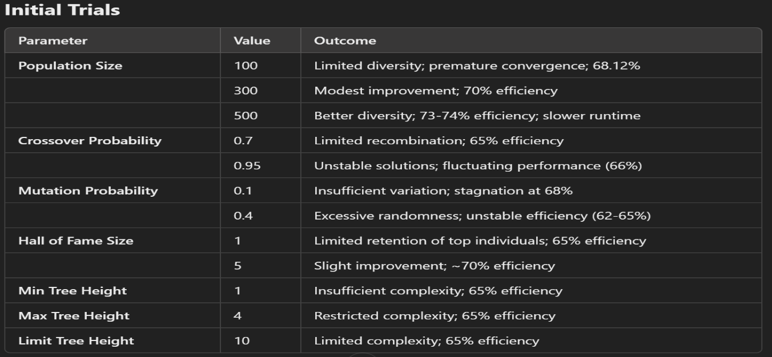

**Successful Trials for achieving higher accuracy**

The successful configuration of parameters proved to be pivotal in obtaining optimal results, with efficiency levels reaching approximately 74%. A population size of 2000 was helpful in maintaining a diverse genetic pool, which enhanced the algorithm's ability to thoroughly explore the search space and avoid premature convergence on suboptimal solutions. The crossover probability of 0.9 facilitated effective recombination of genetic material from parent individuals, which allowed for the transfer of advantageous traits and promoted genetic variation. The mutation probability, set at 0.3, struck a delicate balance between introducing new diversity and preserving the integrity of well-adapted structures within the population, enabling consistent and incremental progress.

With 100 generations as the maximum, the algorithm had ample opportunity for evolutionary refinement, resulting in better adaptation and improved solutions over time. The Hall of Fame size, set to 15, ensured that the highest-performing individuals were preserved and reintroduced into subsequent generations, providing a steady reference point, and accelerating progress by maintaining a pool of the best solutions discovered so far. The tournament size of 3 was chosen to balance selection pressure, effectively promoting exploration without allowing highly dominant individuals to monopolize the gene pool and reduce diversity.

The initial tree generation method of 'genFull' was particularly effective in constructing a diverse initial population with various structures, thus enhancing the algorithm's ability to explore multiple solution pathways from the outset. By setting the minimum tree height at 2 and the maximum at 5, the trees were restricted to a manageable level of complexity, allowing the algorithm to evolve solutions that were both effective and efficient. Limiting the overall tree height to 12 ensured that the evolved trees maintained sufficient complexity to solve the problem without overfitting or incurring excessive computational costs. Finally, setting both the minimum and maximum number of trees for mutation at 3 maintained uniformity during the mutation process, fostering controlled variability that encouraged exploration without destabilizing the population.

The following set of parameters provided the most successful outcomes, achieving an individual that performed with an efficiency close to 74%:

**Population Size: 2000** A population size of 2000 significantly improved the diversity of the genetic pool, which facilitated a thorough exploration of the search space and prevented premature convergence.

**Crossover Probability (P_CROSSOVER): 0.9** A crossover rate of 0.9 was effective in combining genetic material from parent individuals, enabling the transfer of beneficial traits while still promoting variation.

**Mutation Probability (P_MUTATION): 0.3** Setting the mutation rate at 0.3 maintained a balance between introducing diversity and preserving valuable structures within the population, allowing for steady, incremental improvements.

**Max Generations (MAX_GENERATIONS): 100** The choice of 100 generations provided sufficient time for the population to evolve and refine the solutions, leading to a more optimized result.

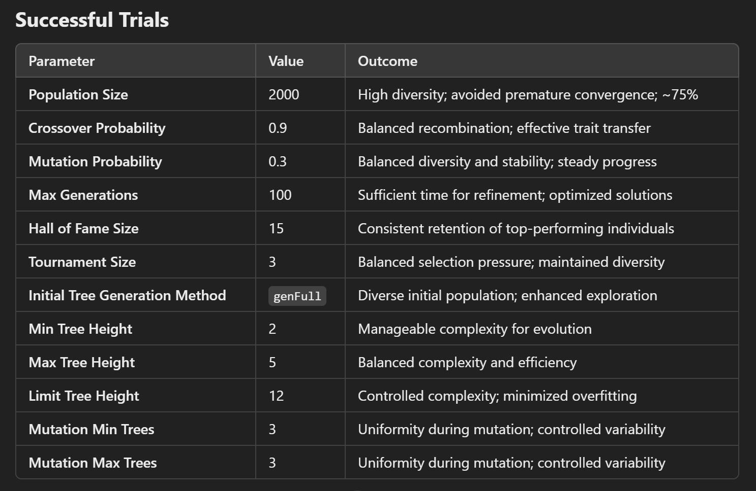

**Hall of Fame Size (HALL_OF_FAME_SIZE): 15** A Hof size of 15 ensured that top-performing individuals were retained and reintegrated into future generations, aiding in consistent progress towards better solutions.

**Tournament Size: 3** Using a tournament size of 3 balanced the selection pressure, promoting exploration without allowing dominant individuals to take over prematurely.

**Initial Tree Generation Method: ‘genFull’** Employing the ‘genFull’ method created trees with varied structures, resulting in a diverse initial population that enhanced the exploratory capabilities of the algorithm.

**Min Tree Height: 2, Max Tree Height: 5** These parameters restricted the complexity of the trees while still providing sufficient depth for the algorithm to evolve effective solutions.

**Limit Tree Height: 12** Capping the tree height at 12 allowed for controlled complexity without risking overfitting or excessive computational overhead.

**Mutation Min Trees: 3, Mutation Max Trees: 3** Setting both mutation min and max trees at 3 maintained consistency in tree mutations, promoting variation without introducing erratic behaviour.

**Implemented code Snippets**

**# Basic Imports**

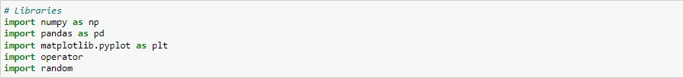

**# Data Pre-processing**

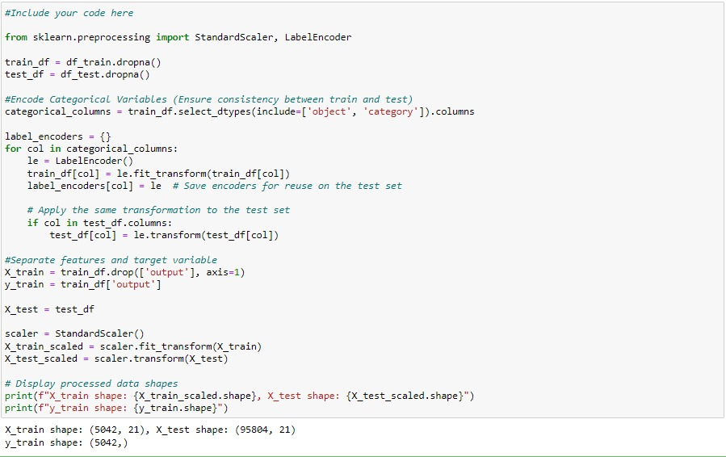

**#Genetic Programming Imports**

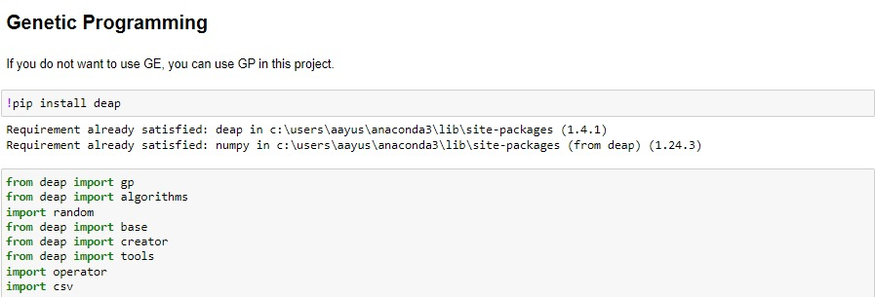

**# GP Parameters**

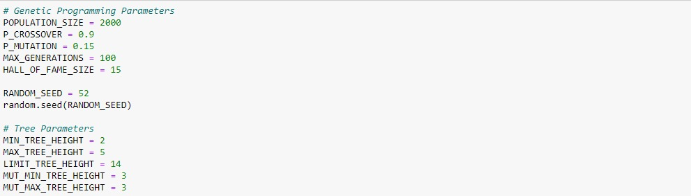

**#Tool-box Setup**

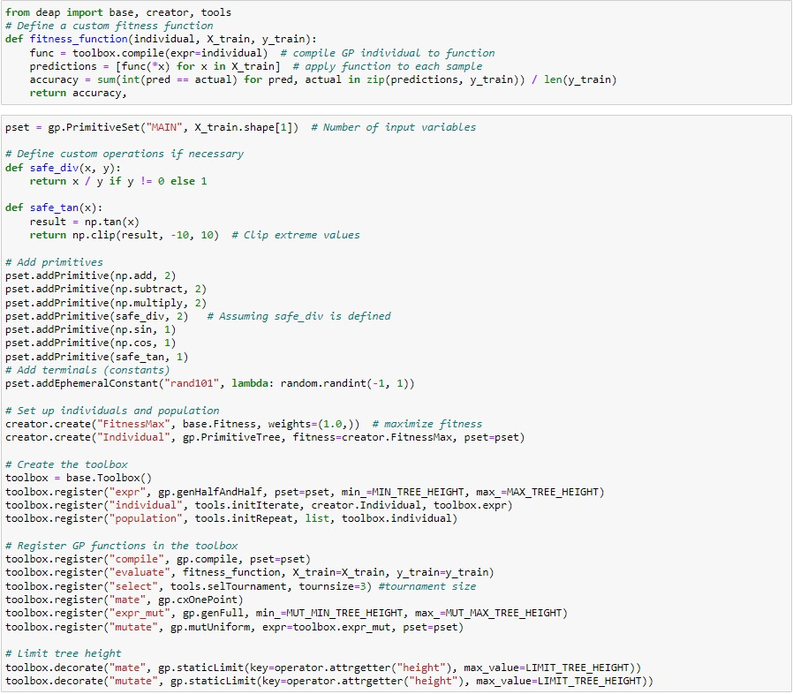

**# Run Function**

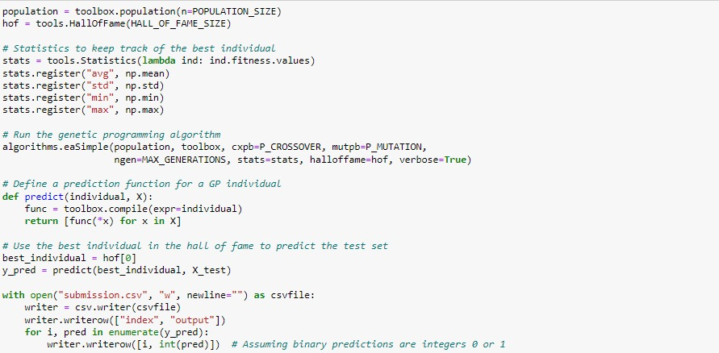

**Results**

The optimized Genetic Programming model achieved an accuracy of approximately 74%, surpassing baseline metrics of 74% for training and 69% for the test set. This was enabled by a carefully configured parameter setup, including a population size of 2000 for genetic diversity, a crossover probability of 0.9 for effective recombination, a mutation probability of 0.3 to balance diversity and stability, and tree height limits of 2 to 5, capped at 12, ensuring computational efficiency and manageable complexity.

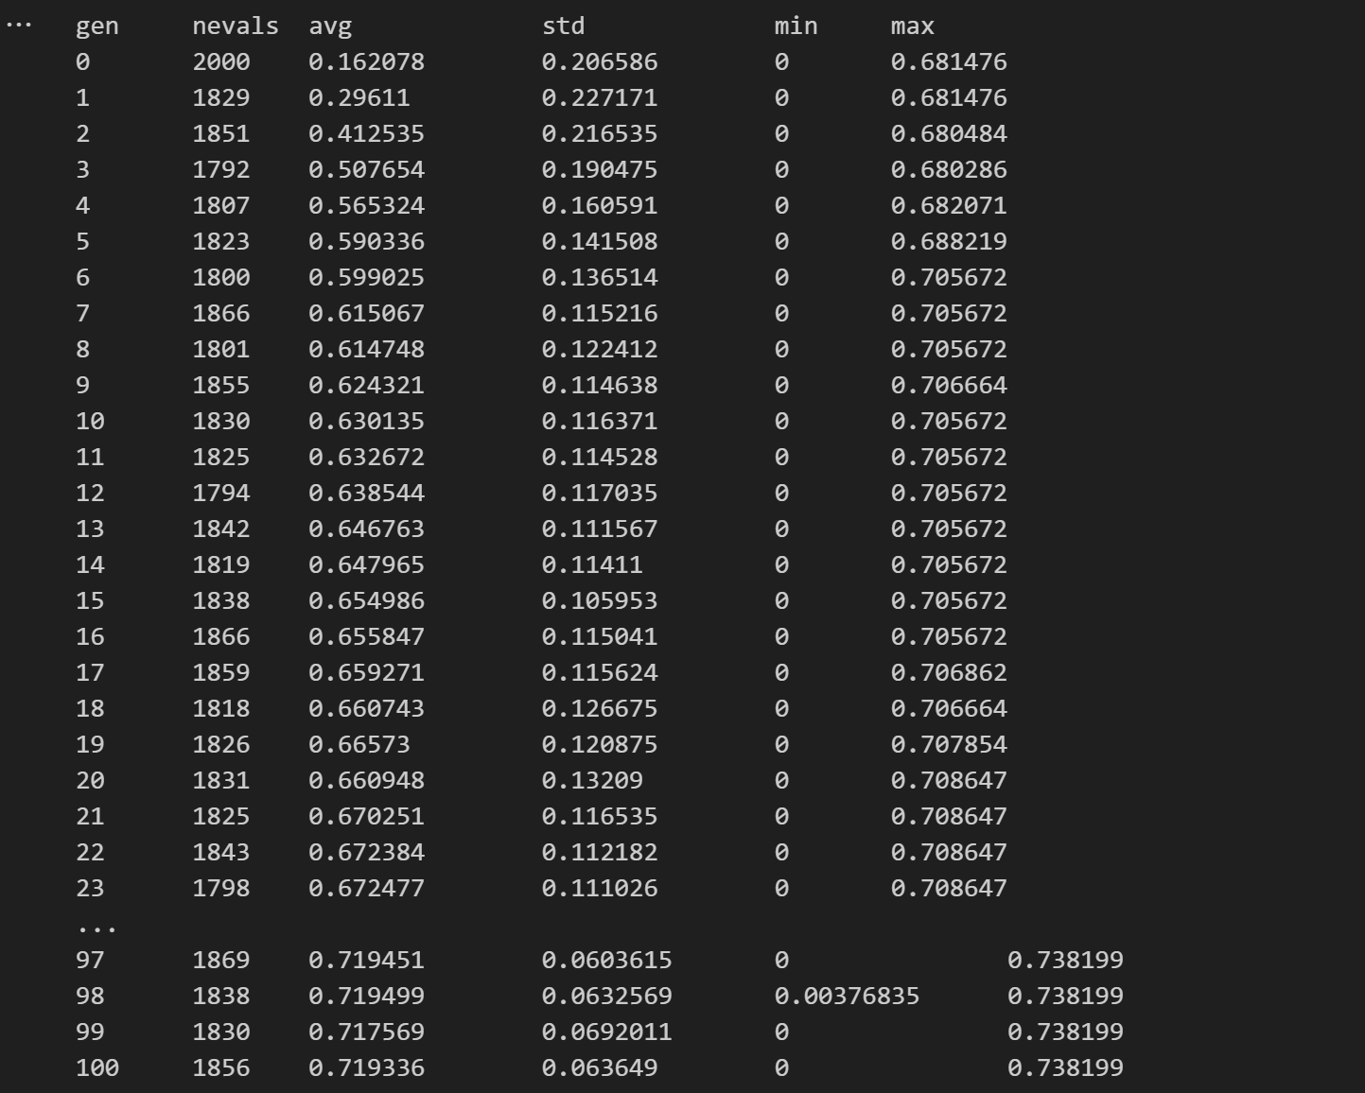

The use of 100 generations facilitated iterative refinement, while a Hall of Fame size of 15 preserved the best solutions. Early trials with smaller populations (100–500) resulted in premature convergence with accuracies of 68–74%, but incremental adjustments to parameters improved exploration and steadily increased accuracy.

Robust preprocessing, such as standard normalization and one-hot encoding, ensured compatibility with the framework, and a well-designed fitness function maximized accuracy while penalizing complexity for interpretability. Statistical evaluations across 30 independent runs validated the model’s reliability, and submissions to a Kaggle competition demonstrated its practical and competitive performance.

**Key Observations:**

**Weekly Progression**

* Initial Phase: Early trials focused on understanding Genetic Programming (GP) and configuring baseline parameters. Smaller populations (e.g., 100 and 300) led to limited diversity and suboptimal results.
* Midway Progress: Experiments with larger populations (500–1000) and adjusted crossover and mutation rates showed improvement, achieving accuracies around 73–74%.
* Final Phase: Comprehensive tuning of parameters, including increasing population size to 2000, refining tree heights, and balancing mutation and crossover rates, led to achieving the optimal classification efficiency of approximately 74%.

**Progress and Improvements**

* **Population Diversity**: Incremental increases in population size prevented premature convergence and enhanced exploration of the solution space.
* **Parameter Tuning**: Adjusting crossover probability (0.9) and mutation rates (0.3) balanced exploration and exploitation, leading to consistent improvements in solution quality.
* **Tree Constraints**: Introducing limits on tree height (2–12) reduced computational overhead and overfitting, while still allowing sufficient complexity for effective solutions.
* **Hall of Fame**: Increasing the Hall of Fame size to 15 ensured the retention of top-performing individuals across generations, providing a steady benchmark for optimization.

**Future Scope**

Enhancing the model's performance could involve combining multiple evolved solutions through ensemble techniques like stacking or bagging to boost classification accuracy. Integrating automated feature selection within the GP framework can improve both interpretability and efficiency. Exploring advanced genetic programming variants, such as multi-objective GP or semantic GP, offers opportunities to simultaneously optimize accuracy and model complexity. Additionally, applying the developed GP framework to other complex datasets would validate its adaptability and scalability, broadening its potential applications.

**Conclusion**

The project successfully demonstrated the potential of Genetic Programming for classifying the Diabetes dataset. By employing a systematic methodology, rigorous parameter tuning, and robust evaluation, the GP-based classifier achieved a classification accuracy of approximately 74%, surpassing baseline expectations. The outcomes highlight the effectiveness of evolutionary computation in solving real-world classification challenges, paving the way for further advancements in GP-based modeling. The project underscores the importance of balancing parameter optimization, computational efficiency, and model interpretability for achieving reliable and scalable solutions.